**PROJECT: GBMES**

**ACCEPTANCE TEST PROCEDURE**

**FOR**

**ACCE RUGGED MONITOR 19"**

**BEL Part No:** **4461 722 603 28**

**(Designed by BEL – Hyderabad)**

**Checked By**

**BEL QC - Hyderabad**

**Prepared By**

**BEL-Hyderabad**

**Approved By**

**DGAQA**

*The Document is supplied on the express terms that it is to be treated as confidential and that it may not be copied, used or disclosed to others for any purpose except as authorized by Bharat Electronics, Hyderabad.*

**Bharat Electronics**

**Industrial Estate, Nacharam,**

**Hyderabad -500076,**

**Telangana,**

|  |  |
| --- | --- |
| **INDIA.**  **Telephone:** | **040 27194208** |
| **Fax:** | **040 27151243** |

|  |  |  |  |  |  |
| --- | --- | --- | --- | --- | --- |
| ISSUE | PAGE NO. | CP NO. | DATE | CHANGE | APPROVED BY |
| P1 |  |  | 20.10.16 | ORIGINAL |  |
|  |  |  |  |  |  |
|  |  |  |  |  |  |
|  |  |  |  |  |  |
|  |  |  |  |  |  |
|  |  |  |  |  |  |
|  |  |  |  |  |  |
|  |  |  |  |  |  |
|  |  |  |  |  |  |
|  |  |  |  |  |  |
|  |  |  |  |  |  |
|  |  |  |  |  |  |
|  |  |  |  |  |  |
|  |  |  |  |  |  |
|  |  |  |  |  |  |
|  |  |  |  |  |  |
|  |  |  |  |  |  |
|  |  |  |  |  |  |
|  |  |  |  |  |  |
|  |  |  |  |  |  |
|  |  |  |  |  |  |

THIS IS AN ELECTRONICALLY APPROVED DOCUMENT, HENCE DOES NOT REQUIRE SIGNATURE

**This document describes the procedure for carrying out Acceptance Tests on ACCE RUGGED MONITOR 19"**

THIS IS AN ELECTRONICALLY APPROVED DOCUMENT, HENCE DOES NOT REQUIRE SIGNATURE

**CONTENTS**

|  |  |  |
| --- | --- | --- |
| **SL.NO.** | **DESCRIPTION** | **PAGE NO.** |
| 1 | Introduction | 5 |
| 1.2 | Reference Documents | 6 |
| 2.0 | Test Equipment Required | 6 |
| 3.0 | Physical Inspection | 6 |
| 4.0 | Functional Test Procedure | 7 |
| 5.0 | Defect /Failure Analysis | 9 |
| 6 | Test Data Records | 10 |
| 7 | Defect Investigation Report | 12 |

1. **INTRODUCTION:**

This document outlines the procedure for conducting ACCEPTANCE tests for the RUGGED 19" MONITOR which is an accessory of LCD DISPLAY WITH KEYBOARD & TRACKBALL of GBMES system.

This item is listed under Sl .No.14 of Manufacturer’s Recommended List of Spares

(MRLS) in the contract for GBMES systems.

This item is being supplied by M/s Datasol Pvt Limited, Bangalore.

**1.1 Brief Description:**

The IDS-3119 Embedded Open Frame Monitor series offers flexible options for LCD, signal interface and chassis mounting. Resolution supports up to1280 x 1024 .Dual signal interface with VGA & DVI .The series supports rear and VESA mounting. The integrated brackets bring the benefits of easy installation and provide flexibility for different applications.

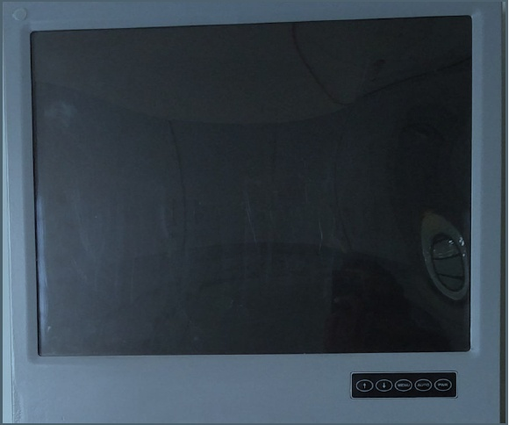

**Fig-1: Image of RUGGED 19" MONITOR**

## 1.2 REFERENCE DOCUMENTS

1.2.1 QTP Document Ref: QTP for p/no. 4461 722 601 34 ver P1, dtd 10.06.16

1.2.2 ESS Tests: COC from OEM

1.2.3 MDI/BOM Part no: Not applicable

1.2.4 BEL PO No.. BEPO / HD4 / 4000057921 dated 05.04.2016

1.2.5 Approved Specifications are as per BEL PP drawing.

1.2.6 Contract No. AIR HQ/S/96135/69/1/ASR Dated 31/07/2015.

1.2.7 SOFTWARE CERTIFICATION - Not applicable

1.2.8 FAILURE ANALYSIS - Refer Appendix-A

1.2.9 MTBF Value of the Sub Assy: Ref BEL letter no. 4706/07/12 dtd 19th Aug 2016 to

AHQ.

1.2.10. Packing Drawing No: 9672 001 084 83

1.2.11. Delivery Set List: Enclosed at Annexure B.

**2.0 TEST EQUIPMENT REQUIRED:**

* + 1. CPU of a standard PC - 1 No. (Straight)
    2. Power cables - 2 Nos.
    3. Video cable - 1 No.
    4. USB Cables - 2 Nos.

## 3.0 PHYSICAL INSPECTION:

3.1 Visual:

1.Check the Display for any damages

2. Check if the power circular connector is properly mating at the Dispaly end and also clearly inserted at the power socket.

3. Check all the connectors power & signal for any loose pins/wires.

4.Note down the result in TDR-1.

**3.2 Dimensions & Drawing Verification:**

Physical inspection of the unit is to be carried out wrt dimensions, mounting and other details as per drawing and note down the measured dimensions in TDR-1.

**Dimensions:**

The following are the dimensions of the Rugged Monitor 19” :

|  |  |  |
| --- | --- | --- |
| **Sl.No** | **Description** | **Specified Dimension(mm)** |
| 1 | Width | 425 ± 1 |
| 2 | Height | 40 ± 1 |
| 3 | Rear Depth | 370 ± 1 |
| 4 | Front Depth | 400 ± 1 |
| 5 | Weight | < 6Kgs |

**4.0 Functional Test Procedure:**

1. Connect the DVI cable from PC to Display and give the 12V Power Supply to Display.

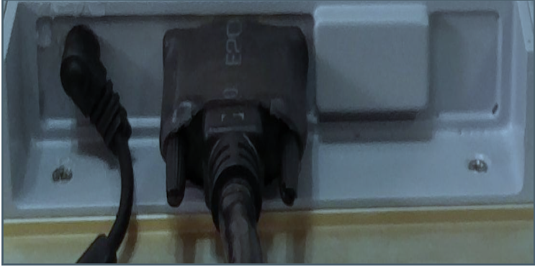

1. After switching ON the power to Display & PC check the system gets booted and display seen on the screen.

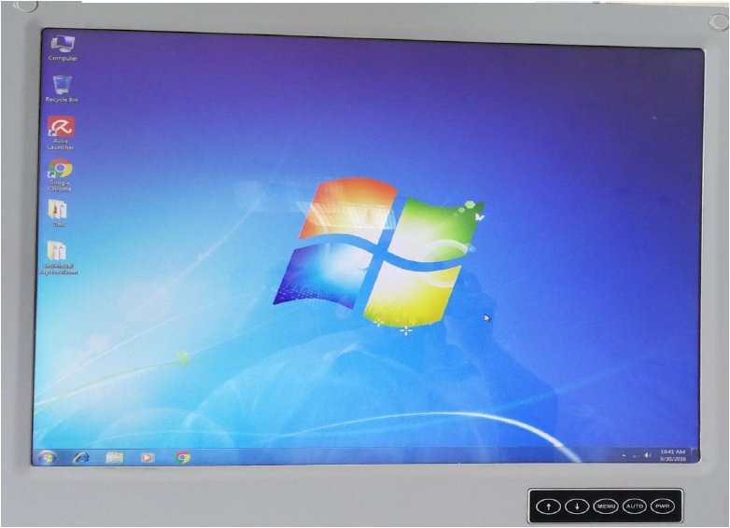

1. To check the resolution Right click upon the Desktop and select the Screen resolution.

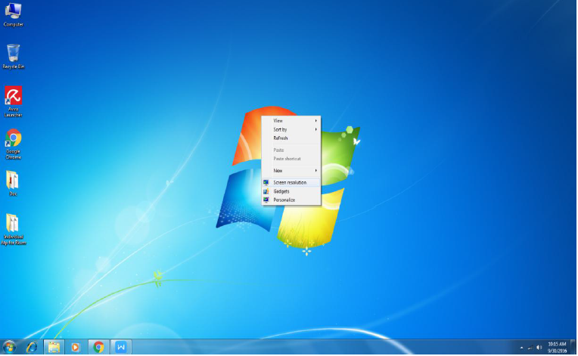

1. Set the Resolution up to 1280 X 1024 and check if the set resolution is supported and displayed on the screen. Note down the results in TDR-2.

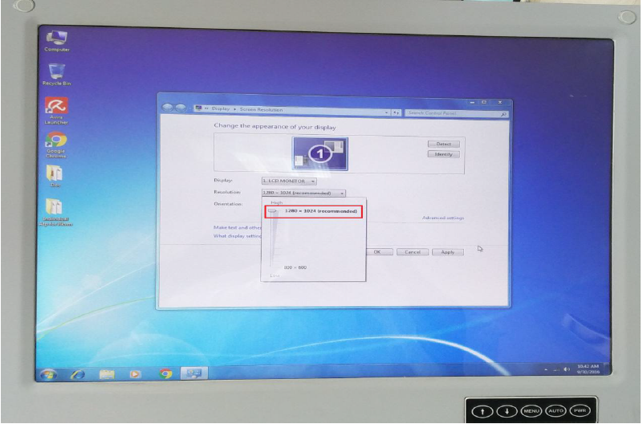

5 After checking, shutdown the system and switch off the Display Unit.

**ENVTRONMENTAL STRESS SCREENING (ESS):**

As the item is an LCD monitor, ESS shall not be done on the unit.

Visual/Physical Test

Electrical Test

**Flow Chart for ATP**

**5.0 Defect / Failure Analysis:** Defect/failure investigation is to be done, entered in the format mentioned in **Appendix-A** for any failure during any of the tests and to be filed with the results.

**TEST DATA RECORD-1**

**Sl.no. Date:**

**Test condition:**

**1. PHYSICAL INSPECTION**

|  |  |  |  |
| --- | --- | --- | --- |
| **S.No** | **Test** | **Requirement** | **Result** |
| 1 | Display damages check | No damages | OK /NOT OK |
| 2 | All the connectors power & signal | No loose pins / wires | OK /NOT OK |

**2. Dimensional Check For Display**

|  |  |  |  |  |
| --- | --- | --- | --- | --- |
| **S.No** | **Description** | **Specified Dimensions(mm)** | **Measured**  **Dimensions(mm)** | **Result** |
| 1 | Width | 425 ± 1 |  | OK /NOT OK |
| 2 | Height | 40 ± 1 |  | OK /NOT OK |
| 3 | Rear Depth | 370 ± 1 |  | OK /NOT OK |
| 4 | Front Depth | 400 ± 1 |  | OK /NOT OK |
| 5 | Weight | < 6Kgs |  |  |

RESULT : OK / NOT OK

OEM .Rep BEL-QC.Rep DGAQA Rep

**TEST DATA RECORD-2**

**Sl.no. Date:**

**Test condition:**

**FUNCTIONAL TEST:**

|  |  |  |  |
| --- | --- | --- | --- |
| **S.No** | **TEST** | **REQUIREMENT** | **RESULT** |
| 1 | **Fuctionality of Display:**  System booting display seen on the screen of Display. | **Observe:**  Resolution up to 1280 X 1024 | OK / NOT OK |

RESULT : OK / NOT OK

## 

## OEM .Rep BEL-QC.Rep DGAQA Rep

**Appendix A**

|  |  |  |  |  |
| --- | --- | --- | --- | --- |
| **DIR**  ***Defect***  ***Investigation***  ***Report*** | **Unit Description:**  **Unit Sl. No.:** | | | |
| DI NO. | TYPE OF MODIFICATION | | | |
| DATE: | H/W | S/W N/A | | BOTH N/A |
| S/W VERSION: N/A | | | CHECK SUM: | |
| PROBLEM REPORTED DURING: | | | | |
| PROBLEM DESCRIPTION: | | | | |
| MODULE / COMPONENT AFFECTED: | | | | |
| DEFECT ANALYSIS & CAUSE OF PROBLEM: | | | | |
| REPAIR / REMEDIAL ACTION: | | | | |
| FOLLOW UP ACTION: | | | | |

## OEM .Rep BEL Design Rep BEL-QC.Rep DGAQA Rep